PMDS601P ARTIFICIAL INTELLIGENCE LAB
Wumpus World in PROLOG
NAME: J SHINY JASPER NIKKITHA
REG NO: 25MDT1128

Aim

To represent the Wumpus World environment using Prolog knowledge-based inference
and to determine safe locations, hazards, and a safe plan for the agent to achieve its goal.

Problem Description

The Wumpus World is a 4 × 4 environment consisting of rooms connected by passages.
The agent starts in room (1,1) facing East. The world contains:

A single Wumpus (deadly)
Zero or more Pits
One piece of Gold
The agent receives percepts in each room:
Stench: Wumpus is in an adjacent room
Breeze: Pit is in an adjacent room
Glitter: Gold is in the room
Bump: Agent hit a wall
Scream: Wumpus has been killed

Two rooms are adjacent only if they share a common wall (not diagonal).
The agent can perform the actions: Forward, TurnLeft, TurnRight, Grab, Shoot,
Climb.

The goal is to:
1. Find and Grab the gold
2. Return to (1,1)
3. Climb out of the cave alive

The agent must use inference to avoid the Wumpus and Pits based on the percept
rules:
Breeze(X, Y ) → ∃ Pit in Adjacent Cell
Stench(X, Y ) → ∃ Wumpus in Adjacent Cell

PROLOG CODE :

% Percepts
stench(1,2).
breeze(1,3).
glitter(2,3).

% Adjacent relationship
size(4).
adjacent(X,Y,X1,Y) :-
X1 is X+1, size(N), X1 =< N.
adjacent(X,Y,X1,Y) :-
X1 is X-1, X1 >= 1.
adjacent(X,Y,X,Y1) :-
Y1 is Y+1, size(N), Y1 =< N.
adjacent(X,Y,X,Y1) :-
Y1 is Y-1, Y1 >= 1.

% Inference rules
possible_pit(X,Y) :- breeze(A,B) , adjacent(A,B,X,Y).
possible_wumpus(X,Y) :- stench(A,B) , adjacent(A,B,X,Y).
% Gold is always safe
safe(X,Y) :- gold(X,Y).

% Other cells are safe if no possible pit or wumpus
safe(X,Y) :-
\+ possible_pit(X,Y),
\+ possible_wumpus(X,Y),
\+ gold(X,Y).

% Starting cell always safe
safe(1,1).

% Initial states
:-dynamic(agent/2).
:-dynamic(wumpus/2).
:-dynamic(gold/2).
agent(1,1).
wumpus(1,3).
gold(2,3).
% Actions
move(X,Y) :-
agent(A,B),
adjacent(A,B,X,Y),
safe(X,Y),

format('Moved to (~w,~w)~n', [X,Y]).

grab_gold :-
agent(X,Y),
gold(X,Y),

format('Gold grabbed at (~w,~w)!~n', [X,Y]).

shoot :-
agent(X,Y),
wumpus(WX,WY),
adjacent(X,Y,WX,WY),

write('Wumpus shot! Screeaaam!'), nl.

climb :-
agent(1,1),
write('Agent climbed out safely with the gold!'), nl.

where_am_i :-
agent(X,Y),
format('Agent is at (~w,~w).~n', [X,Y]).

% Base case: reached gold
safe_path((X,Y), _, [(X,Y)]) :- glitter(X,Y), !.

% Recursive case: move to adjacent safe cells
safe_path((X,Y), Visited, [(X,Y)|Path]) :-
adjacent(X,Y,NX,NY),
safe(NX,NY),
\+ member((NX,NY), Visited),
safe_path((NX,NY), [(NX,NY)|Visited], Path).

% Wrapper for easier querying
safe_path(Start, Path) :-
safe_path(Start, [Start], Path).

OUTPUT:

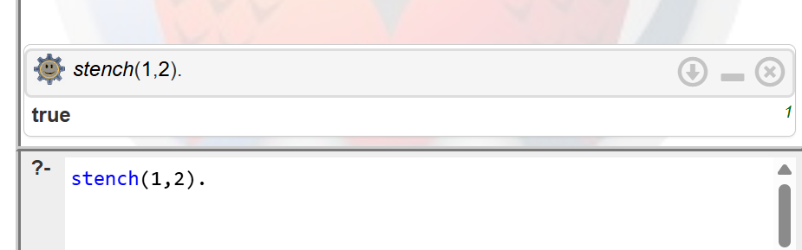
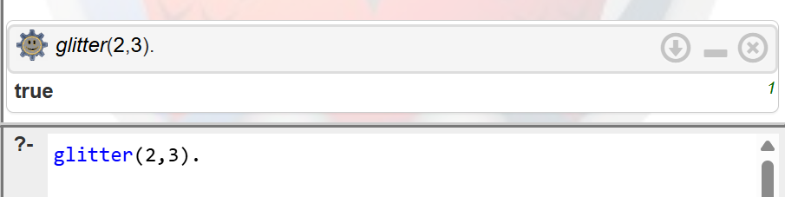
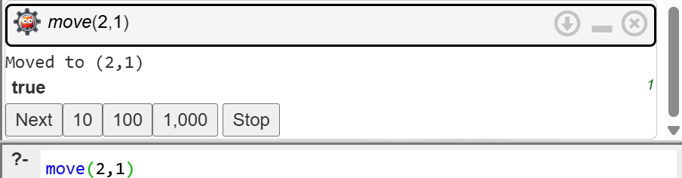

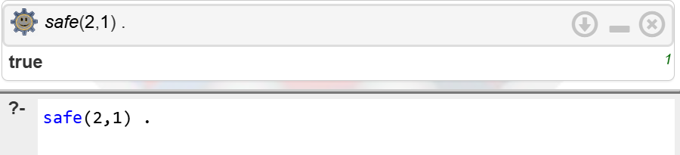

2.
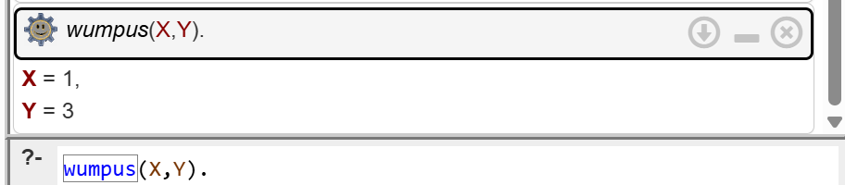

3.
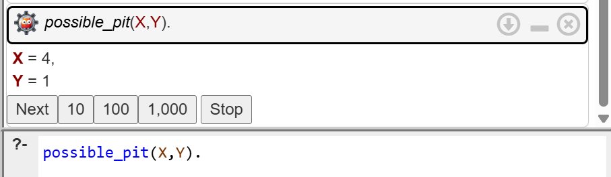

4.
